Module 9 Robots R Us
SPEAKING
- Discuss the probability of a job to be automated
- Share your views on the pros and cons of robotics
- Speak about robots for hazardous applications

LISTENING
- Listen to a lecture on machine learning

READING
- Read about different kinds of robots
- Read about the problem of defining a robot
- Read about the robotic arm
- Read about the artificial intelligence in robotics
- Read about robots for hazardous applications

WRITING
- Write a report of a robot’s actions
- Describe graphs and charts

VIDEO CONTENT
- 10 amazing robots
- Atlas by Boston Dynamics
- First industrial robot
- Robotic Cake Cutting & Tray Packing System
- TED lecture by Anthony Goldbloom
- DARPA robotic challenge

Grammar
- Complex Object
- Complex Subject
- Infinitive with FOR
- Infinitive structures with TOO and ENOUGH

Word formation:
Prefixes with multiple meanings –OUT, IN

Essential vocabulary

assist v

bar chart

branch n

chore n

core adj

define v

design v

-fold adj

graph n

grasp v

grip v

hazardous adj

implication n

in turn

input n

joint n

link n

obstacle n

otherwise adv

outperform v

output n

perform v

pie chart

precisely adv

rather than conj

reasoning n

serve v

share n

tackle v

tighten v

Module 9 Lesson 1 ROBOTS, ROBOTS EVERYWHERE

1 Look at the pictures and discuss the questions below in small groups.
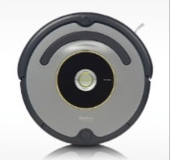
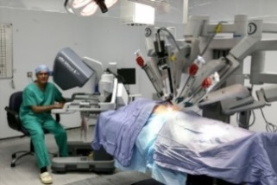
- In what everyday situations do robots work?
- *What vocabulary associated with robots can you recall?
- Speak about robots’ abilities:

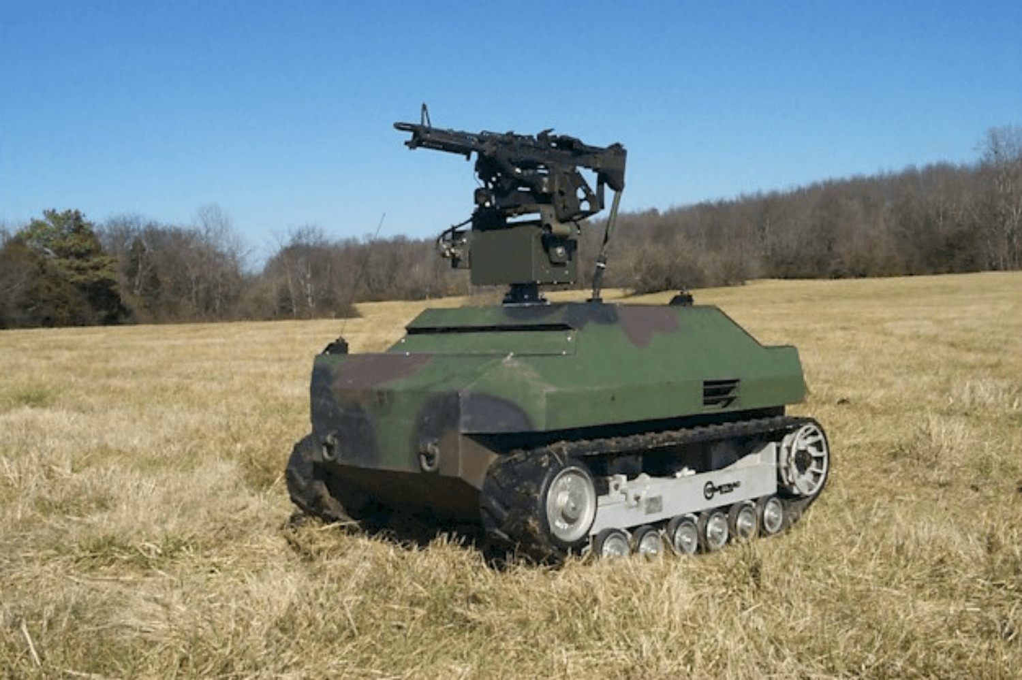
This robot can

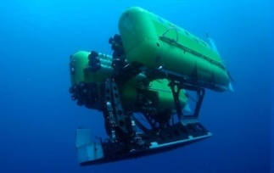
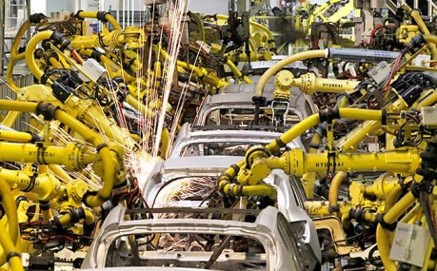
This robot is capable of
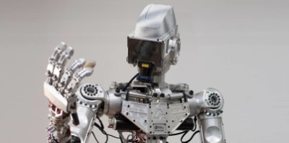

2 There are different classifications of robots: by application, by movement, by power source etc. What classification is given below?

Defence (military)/ domestic/ entertainment/ industrial/ medical/ space

3 Read the text and match the category from Ex. 2 to its description.

________ (1) robots are fixed manipulators which perform in various working environments. They perform various general-purpose tasks like welding, painting, machining, etc.

Non-Industrial or Special Purpose: These are robots which assist humans in their chores

_______(2) : There has been an increasing use of robots for surgery, rehabilitation and training. They are not meant to replace the doctors but serve as assistants to the surgeon.

_______ (3): Thanks to robotic technologies, exploration of various celestial bodies has become a reality. Tasks like space manipulation, surface mobility and scientific experiments can be performed by robots.

_______(4) robots include bomb disposal robots, transportation robots and reconnaissance drones. Equipped with infrared sensors, these robots react more rapidly than humans in emergency and hazardous situations.

________ (5) robots are used to perform daily tasks at home, such as robotic vacuum cleaner, cleaning robots.

__________(6) robots are used in amusement parks, joy rides, sports, etc. Examples include KUKA Robocoaster (amusement ride robot), Honda’s Asimo, Sony’s Aibo, etc.

4 In Ex. 3 find the words that mean the same as the words below.

dangerous

everyday job

to do

to function

to help

5 In pairs study the classification of robots by movement. Fill in the missing categories.

Bipedal flying legged mobile single

6 Watch the video “10 Amazing Robots”. Match the robots to the categories.

Domestic robot ____ 10. Asimo

Space robot _______

Military robot _____

Rescue robot _____

Education robot _____

Flying robot ______

Wheeled robot ______

Bipedal robot ________

Quadrupedal robot ______

7 Discuss the questions in small groups.

Which of these robots is the least useful?

Which of these robots has the most commercial value?

Which robot(s) will really change the world?

8 Work in a small group and give your definition of a robot

A robot is ………. that ………………., for example ……………….. .

9 Read the text and find the definition of robot.

define v определять, давать определение
conundrum n головоломка, загадка
implication n значение, смысл; have implications for повлиять на
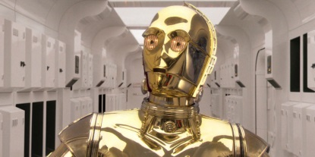
obstacle n препятствие
embody v воплощать
in turn в свою очередь
core adj ключевой, основной

When you hear the word “robot,” the first thing that probably comes to mind is a metallic humanoid, like C-3PO. But there’s also the Roomba, and autonomous drones, and technically also self-driving cars. A robot can be a lot of things these days.
With so many different kinds of robots, how do you define what one is? It's a physical thing―engineers agree on that, at least. But ask three different roboticists to define a robot and you’ll get three different answers. This isn't a trivial semantic conundrum: Thinking about what a robot really is has implications for how humanity deals with the unfolding robo-revolution.
I’d like you to think about two drones. One you have to pilot yourself, and the other is autonomous, taking off, navigating obstacles, and landing all on its own. Are these both robots? Nope.
“I would say that a robot is a physically embodied artificially intelligent agent that can take actions that have effects on the physical world,” says roboticist Anca Dragan of UC Berkeley. According to that definition, a robot has to make decisions that in turn make it useful―that is, avoiding things like running itself into trees. So your dumb, cheapo RC quadcopter is no more a robot than an RC car. An autonomous drone, however, is a thinking agent that senses and interacts with its world. It’s a robot.
Intelligence, then, is a core component of what makes a robot a robot and not a wind-up toy. Kate Darling, a roboticist at the MIT Media Lab, agrees. “My definition of a robot, given that there is no very good universal definition, would probably be a physical machine that's usually programmable by a computer that can execute tasks autonomously or automatically by itself,” she says. “What a lot of people tend to follow is this sense, think, act paradigm." An RC drone can act, but only because you order it to. It can’t sense its environment or think about its next action. An autonomous drone, however, can do all three. It’s a physical embodiment of an artificial intelligence.

10 Read the text again and choose the right answer.

- What is the main attribute of a robot?
- a microchip
- remote control
- intelligence
- a motor

- A remote control drone is not a robot because …
- it is cheap
- it can’t make decisions
- it is not reliable
- it has no practical use
GRAMMAR: The complex object
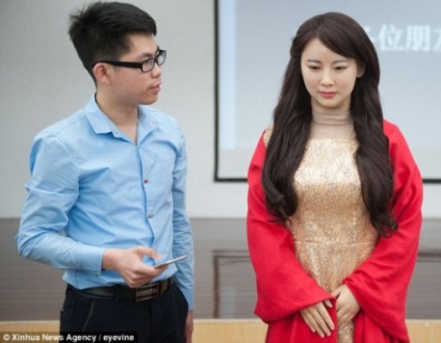
11 Answer these questions in pairs. Do you agree on everything?

- Factory workers expect robots to steal their jobs.
- People love watching robots perform difficult tasks.
- We want robots to look like human beings.
- Robots will cause people to degenerate intellectually.
- Humanoid robots make us feel uncomfortable.

How will you translate the sentence: Industry workers expect robots to steal their jobs?

- Рабочие ожидают роботов, чтобы занять их рабочие места.
- Рабочие ожидают, что роботы займут их рабочие места.

Во всех 5 предложениях выше используется конструкция Сложное дополнение (Complex object)
подлежащее сказуемое дополнение инфинитив
Industry workers expect robots to steal …
Robots will cause people to degenerate
We watch robots perform …
People want robots to look like …
Humanoid robots make us feel …

На русский язык предложения с такими конструкциями переводятся в большинстве случаев с помощью придаточных предложений:

Рабочие ожидают, что …
Роботы станут причиной того, что люди …
Мы наблюдаем за тем, как …
Люди хотят, чтобы роботы ….
BUT! Человекоподобные роботы заставляют нас чувствовать себя неуютно.

КОНСТРУКЦИИЯ «СЛОЖНОЕ ДОПОЛНЕНИЕ» УПОТРЕБЛЯЕТСЯ после глаголов, обозначающих

- умственную деятельность:
to know
to think
to consider
to believe
to suppose
to expect
to imagine
to find
to assume

- чувства и эмоции:
to like
to dislike
to love
to hate
cannot bear

- приказ или разрешение:
to order
to allow
to permit
to make*
to have*
to get
to force
to cause

*После этих глаголов инфинитив употребляется без частицы to
- чувственное восприятие**
to hear **
to see**
to watch**
to feel**
to observe**
to notice**
**После этих глаголов инфинитив употребляется без частицы to
**После этих глаголов также можно употребить ING форму для того, чтобы продемонстрировать процесс протекания действия

12 Fill in the gaps with the suitable verbs. Notice: one verb is extra!
allow/ don’t like/ expect/ have/ see/ would like

- A third of Brits _______ robots to do their household chores soon.
- Humans ________ robots to be too life-like.
- Not many people will _______ robots to look after their children.
- In the video you can _________ the new robot walking over difficult terrain.
- We can ______robots do hazardous jobs for us.

13 Choose the correct option.

1a The audience watched the robot overcoming obstacles.
b The audience watched the robot was overcoming obstacles.

2a The public doesn’t want robots being too smart.
b The public doesn’t want robots to be too smart.

3a What jobs will you let a robot do in your home?
b What jobs will you let a robot to do in your home?

4a We expect them not to look exactly like us.
b We expect they not to look exactly like us.

5a Industrial robots allow that humans and robots to work together.
b Industrial robots allow humans and robots to work together.

6a Would you like that a robot look after you when you are sick?
b Would you like a robot to look after you when you are sick?

7a We prefer robots to do monotonous repetitive work.
b We prefer that robots to do monotonous repetitive work.

8a Industrial robots will force that workers will lose their skills.
b Industrial robots will force workers to lose their skills.

9a Humans should not be made to perform dirty and dangerous jobs.
b. Humans should not be made perform dirty and dangerous jobs.

14 Watch the video about the Atlas robot and tick the actions that you saw the robot do.
- attack the human
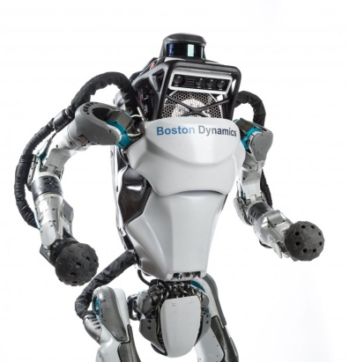
- dance
- fall down
- jump up and down
- keep pace with the human
- lift heavy boxes
- put boxes in place
- straighten itself
- swim
- walk on snow-covered ground

15 *Describe in writing what you saw Atlas and its developers do in the video.
- We could see Atlas open the door.
- We watched the robot walking over difficult terrain.
- We observed a human push the robot.

16 Fill in the gaps in a survey by the British Science Association using Complex Object.

60% expect the use of robots __ lead to fewer jobs within ten years.
36% ________the development of AI to be a threat to humanity.
46% don’t ______ robots ___ have personality.

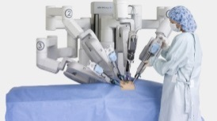
What job will you NOT have a robot do?
53% will not _____ __ _______ perform surgery.
49% will ____ ____ __ ______ drive public buses.
62% ____ ____ ____ __ ____ ______ commercial aircraft.

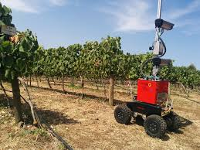
What job will you want a robot to do?
49% will ____ a robot to perform domestic tasks for the elderly or the disabled
48% will _____ _ _____ __ fly unmanned search and rescue missions
45% ____ _____ _ _____ __ fly unmanned military aircraft
70% ____ _____ _ _____ __ monitor crops

Module 9 Lesson 2 ROBOTS AT WORK

17 Decide if the words in pairs are close in meaning and mark them with ≈ or ≠

robotic ≈ automatic

hazardous dangerous

chore problem

assist help

embody use

implication application

define find

serve work

conundrum mystery

implication effect

perform exist

obstacle barrier

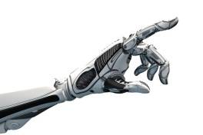

18 Answer the questions in pairs.

- What is the origin of the word ‘robot’?
- What is a robotic arm?
- What kind of work and what kind of tasks are robotic arms designed to perform?
- Is there any similarity between a human arm and a robotic arm? What is it?
- What industries do robotic arms commonly work in?
19 Read the text and check your answers to Ex. 18.

The Robotic Arm

design v 1) разрабатывать, предназначать;

2) проектировать, конструировать

handle v справляться, обращаться с
joint n сочленение
link n звено
increment n шаг, приращение
precisely adv точно
sensor n датчик
rather than conj а не
end effector n рабочий орган
grasp v / grip v– захватывать
drill v сверлить
tighten v затягивать
no matter – вне зависимости от

- The term robot comes from the Czech word robota, generally translated as "forced labor". Indeed, most robots in the world are designed for heavy, repetitive manufacturing work. They handle tasks that are difficult, dangerous or boring to human beings.
- The most common manufacturing robot is the robotic arm. It consists of a number of joints and links. A robotic joint (also called axis) provides relative motion between two links of the robot. The computer controls the robot by rotating individual step (or stepper) motors connected to each joint. Unlike ordinary motors, step motors move in exact increments. This allows the computer to move the arm very precisely, repeating exactly the same movement over and over again. The robot uses motion sensors to make sure it moves just the right amount.
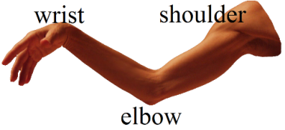
- An industrial robot closely resembles a human arm - it has the equivalent of a shoulder, an elbow and a wrist. Typically, the shoulder is mounted to a stationary base structure rather than to a movable body.
- Your arm's job is to move your hand from place to place. Similarly, the robotic arm's job is to move an end effector from place to place. You can outfit robotic arms with all sorts of end effectors, which are suited to a particular application. One common end effector is a simplified version of the hand, which can grasp and carry different objects. Robotic hands often have built-in pressure sensors that tell the computer how hard the robot is gripping a particular object. This keeps the robot from dropping or breaking whatever it's carrying.
- Most industrial robots work in auto assembly lines, putting cars together. Robots can do a lot of this work more efficiently than human beings because they are extremely precise. They always drill in the exactly the same place, and they always tighten bolts with the same amount of force, no matter how many hours they've been working. Manufacturing robots are also very important in the computer industry. It takes an incredibly precise hand to put together a tiny microchip.

20 Decide if the following statements are true or false.
- A robot can have several links and joints.
- Motors are connected to links.
- The main feature of a step motor is that it is controlled by a computer.
- The type of the end effector used depends on the application.
- A pressure sensor is used to detect objects.
- Robots are used in car plants because they can tighten bolts with greater force than humans.

21 Fill in the gaps with the suitable words from Ex. 19.

1. Robots use _______ to collect information from the environment.
2. A ________ is a mechanism that enables relative motion between parts of a robotic arm.
3. Step motors move in fixed ________.
4 An ___ ______ is the device at the end of a robotic arm, designed to interact with the environment.

22 *Find the English equivalents for the following:
Mеханический манипулятор; рабочий орган; сборочный конвейер; датчик давления; датчик движения; шаговый двигатель; относительное движение; неподвижное основание.

23 Watch the video about Unimate, the first industrial robot, and choose the correct option.

- George Devol believed robots to be preferable to people in jobs that
a. involve repetitive actions
b. require good mechanical skills
c. require high accuracy

- The original purpose of the robot arm by George Devol was …
a. to improve the workers’ life
b. to make production cheaper
c. to improve production quality

- While Devol was working on the invention, Engelberger focused on
a. finding investors
b. finding potential applications
c. finding similar patents

- It was difficult for the robots to be introduced into the US industry because …
a. the industry was not ready
b. the public considered them to be dangerous
c. the industry could not afford them

- Industrial robots became popular in Japan because
a. the Japanese public found them cute
b. they improved the companies’ image
c. they increased productivity

24 *Match the characteristic to the personality.

George Devol | ←had poor business skills | Joe Engelberger
 | had a university degree
 | immediately recognized the commercial potential of the invention
 | tried to find the market for the new invention
 | was a nerd
 | was a self-taught engineer
 | was a serial inventor
 | was a sharp businessman
 | was the father of the first industrial robot
25 Match the end effector to its name.
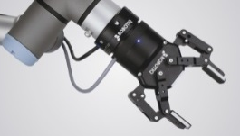  1 | 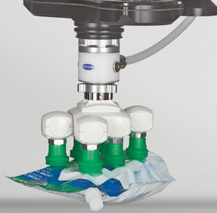  2 | 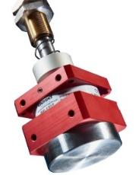  3 | 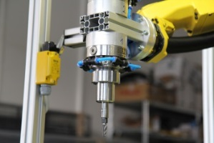  4
suction cap/ vacuum | gripper | drill | magnetic

26 *Watch the video and answer the questions.

  - What items can you see on the conveyor belt?
  - What is the purpose of the assembly line?
  - What kinds of end effectors are used?
  - How many robots are working?
  - What is their productivity?
  - What extra features do they have?

27 Agree or disagree

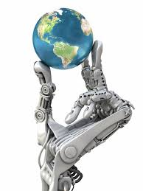
- People seem to be more than ever dependent on robots.
- Robots are likely to rule the world if we do not stop them now.
- Industrial robots were said to have no practical use.
- Robotics is supposed to change the concept of work.

Во всех предложениях выше используется конструкция
Сложное подлежащее (Complex subject)
подлежащее сказуемое инфинитив
People seem to be
Robots are likely to rule
Robots were said to have
Robotics is supposed to change

Истинным сказуемым здесь является инфинитивная конструкция, а формальное сказуемое переводится на русский язык при помощи вводной конструкции и может находиться в начале или середине предложения:

Кажется, что люди как никогда раньше зависят … // Люди, по-видимому, … зависят
Вероятно, роботы станут править миром// Роботы вероятно станут править миром
Говорили, что роботы не имеют практической пользы// Роботы, как говорили, не имеют ….
Предполагается, что робототехника изменит …// ! Робототехника должна изменить

КОНСТРУКЦИЯ «СЛОЖНОЕ ПОДЛЕЖАЩЕЕ» употребляется после глаголов в страдательном залоге, обозначающих
1 чувственное восприятие:  to be heard  to be seen  to be watched  to be felt  to be observed  to be noticed  to be perceived и др. | 2 умственную деятельность:  to be known  to be thought  to be considered  to be believed  to be supposed  to be expected  to be imagined  to be found  to be assumed и др. | 3 сообщение:  to be said  to be reported  to be stated и др.

4 После глаголов в действительном залоге и фраз, выражающих степень уверенности:

to seem
to appear
to prove
to turn out
to happen
to be likely
to be unlikely
to be sure
to be certain

28 Choose the correct option.

- В этом видео было видно, как ATLAS передвигается по пересеченной местности. In the video, ATLAS was seen/ saw to walk over difficult terrain.
- Ожидается, что роботы будут выполнять всю работу по дому в ближайшем будущем. Robots are expected/ Expected robots to do all our household chores in the near future.
- Говорят, что большинство людей доверяют роботам. Most people are said/ Said, most people to trust robots.
- Большинство людей, как говорят, не доверяют роботам. Most people are said/ said to mistrust robots.
- По-видимому, обычные люди не доверяют роботам. The general public seems/ is seemed to mistrust robots.
- Роботы вероятно заменят людей в опасных условиях. Robots are sure/ likely to replace people in hazardous jobs.
- Создается впечатление, что инвестиции в роботов себя не оправдывают. Investments in robotics happen/ appear not to pay off.

29 Transform the given sentences using the prompts in brackets.

- People saw George Devol as an impractical inventor.
George Devol was seen to be an impractical inventor.
- It was supposed that workers would perform monotonous tasks without losing concentration. (Workers were …)
- It was expected that the robotic arm should be able to grasp and lift objects.
(The robotic arm was …)
- The inventor found that pressure sensors were useful for the robotic arm.
(Pressure sensors were …. to be ….)
- It happened so that Devol and Engelberger met by accident. (Deval and Engelberger …)
- The American public perceived robots to be scary and dangerous. (Robots were …)
- It seemed that the situation was hopeless. ( The situation …)
- The industry in Japan considered robots to have a huge potential. (Robots were … in Japan).
- It was reported that the Japanese automotive industry experienced a boom.
(The Japanese automotive industry was …)
- It is believed that Devol and Engelberger had started the industrial robotics.
(Devol and Engelberger are …)

30 *Look at list of the jobs below. Which of them are likely to be taken over by robots? Brainstorm in small groups and check here if you were right

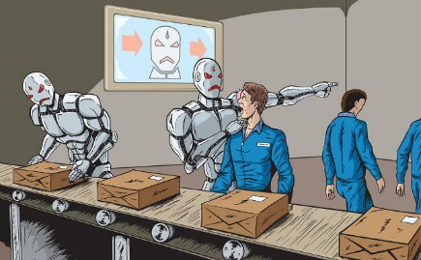
Robots are likely to take postal service workers’ jobs soon.
Robot worker image via shutterstock.com
Human postal service workers are sure to be replaced by robots.
Robots are certain to replace human postal service worker.

Postal service worker, bus driver, university professor, programmer, accountant, cashier, aerospace engineer, mechanical engineer, restaurant cook, fashion model, electronic drafter.

31 Study the visual and answer the questions.
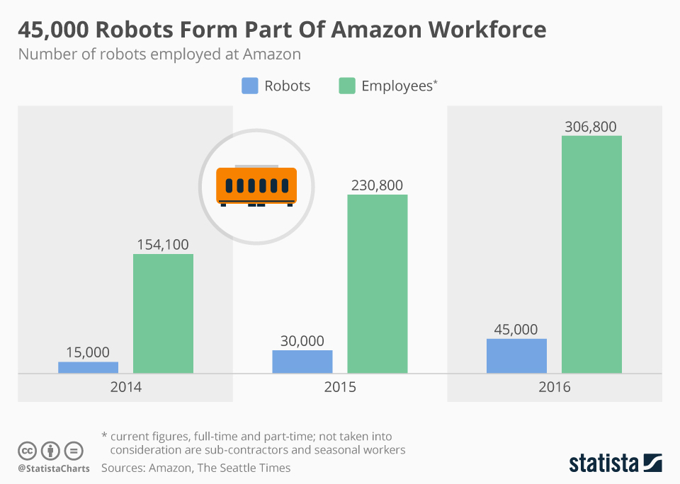

1. What type of diagram is this: a table, a pie chart, a bar chart or a graph?
2. What information does it show? Over what period?
3. How did the size of Amazon workforce change?
4. How did the number of robots in Amazon workforce change?
5. What trend does it indicate?
- The number of... increased/went up/grew by n.
- The number of... decreased/went down n times.
- The number of…. doubled/ tripled.
- The number of... did not change/remained stable
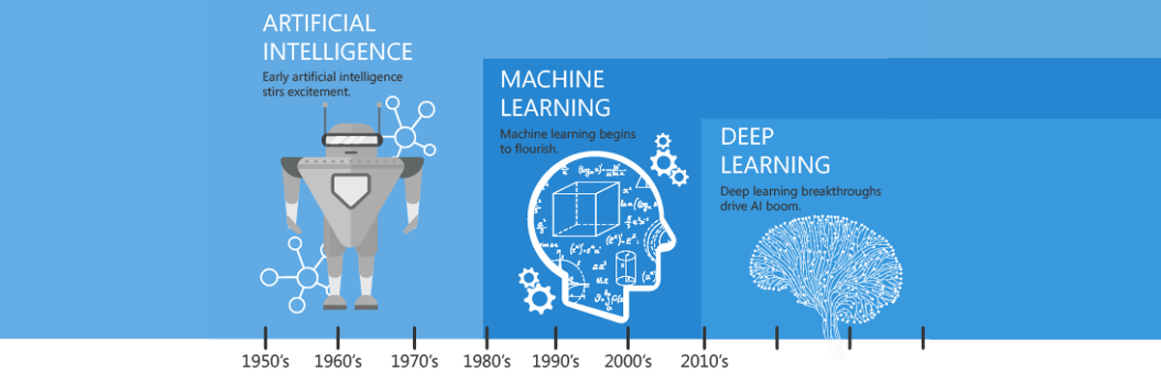

Module 9 Lesson 3 ARTIFICIAL INTELLIGENCE

32 Match the verbs to the nouns (more than one variant is possible)

drill | tighten | handle | navigate | assist | do | perform | overcome
bolts | humans | holes | tasks | obstacles | challenges | chores

33 Look at the list of jobs. Which of them can already be done by robots?

Robots already can  Only humans can  Robots will be able to | - sort mail  - grade school essays.  - assess credit risks.  - diagnose illnesses.  - invent new things.  - conduct financial audit.  - read standard contracts.  - develop business strategies.  - create marketing campaigns.
Watch a TED Talk on machine learning and check your ideas.

34 *Watch the video again and fill in the gaps in the summary.

In 2013, scientists from ________ University estimated that almost ____% of all jobs had a high risk of being automated by machines. This is explained by the advances in machine ________. This technology allows machines to learn from _______ and mimic some of the things that humans can do. In frequent, high-volume tasks machines can ________ humans. However, machines cannot compete with us when it comes to dealing with _______ situations.

35 Work in small groups and decide if the following statement are true or false.

1. Artificial intelligence is used only in robotics.

2. All robots are artificially intelligent.

3. AI algorithms allow robots to understand human language.

4. AI is used to make robots safer for humans.

36 Read the text and check answers to your questions.

Venn diagram диаграмма Венна (из пересекающихся окружностей)

branch v раздел, отрасль

otherwise adv иначе, в ином случае

tackle v браться за, справляться

reasoning n рассуждения

input n данные на входе

output n данные на выходе

Are Robotics and Artificial Intelligence the Same Thing?

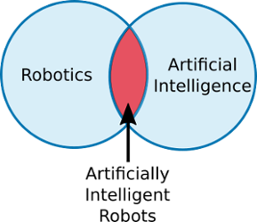
by Alex Owen-Hill on Jul 19, 2017

The first thing to clarify is that robotics and artificial intelligence are not the same thing at all. In fact, the two fields are almost entirely separate. A Venn diagram of the two would look like this:

To understand how these three terms relate to each other, let's look at each of them individually.

What Is Robotics?
Robotics is a branch of technology which deals with robots. Robots are programmable machines which are usually able to carry out a series of actions autonomously, or semi-autonomously.

What Is Artificial Intelligence?
Artificial intelligence (AI) is a branch of computer science. It involves developing computer programs to complete tasks which would otherwise require human intelligence. AI algorithms can tackle learning, perception, problem-solving, language-understanding and/or logical reasoning.
AI is used in many ways within the modern world. For example, AI algorithms are used in Google searches, Amazon's recommendation engine and SatNav route finders. Most AI programs are not used to control robots. Even when AI is used to control robots, the AI algorithms are only part of the larger robotic system, which also includes sensors, actuators and non-AI programming. Often — but not always — AI involves some level of machine learning, where an algorithm is "trained" to respond to a particular input in a certain way by using known inputs and outputs.
The key aspect that differentiates AI from more conventional programming is the word "intelligence." Non-AI programs simply carry out a defined sequence of instructions. AI programs mimic some level of human intelligence.
What Are Artificially Intelligent Robots?
Artificially intelligent robots are the bridge between robotics and AI. These are robots which are controlled by AI programs. Many robots are not artificially intelligent. Up until quite recently, all industrial robots could only be programmed to carry out a repetitive series of movements. Non-intelligent robots are quite limited in their functionality. AI algorithms are often necessary to allow the robot to perform more complex tasks.
37 Study prefixes that can have multiple meanings. Match the examples to each category.
OUT can mean 1) to improve, to make or do something bigger, better, longer etc. OUTPERFORM
2) outside or away from. OUTPUT
Outclass, outdoor, outdo, outflow, outshine, outbuilding, out-box
IN can mean 1) not; negative INFREQUENT
2) inside, into, towards INPUT
Inland, income, inexpensive, indefinite, infiltrate; inorganic,

GRAMMAR

INFINITIVE STRUCTRURES

Предлог FOR позволяет ввести в инфинитивную конструкцию «действующее лицо». Подобные предложения обычно переводятся с помощью инфинитива или придаточных предложений со словом ЧТОБЫ или КОТОРЫЙ.
 | FOR somebody | TO infinitive
It is important | for roboticists | to understand | human interaction
This is the problem | for future generations | to solve.
The best jobs | for a robot | to perform | are in industry.
There will be nothing | For an idea  for us | to be realized,  to do, | you need a lot of effort.  with robots working.

38 Complete the sentences with a “FOR somebody TO do” structure. Use the words provided.

Atlas/ AI robots/ George Devol/ Joe Engelberger/ industrial robots/ machines/ industrial workers/ people/ university professors

- It is possible for AI robots to understand human language.
- To create the first industrial robot was the ambition of a lifetime.
- It was easy to recognize the business potential of engineering ideas.
- It is no problem to perform monotonous repetitive tasks.
- It won’t take long to be replaced by robots.
- To be afraid of robots is quite natural.
- It was a huge advance to navigate obstacles without falling down.
- To be replaced with robots is very unlikely.
- It is almost impossible to outperform humans in creative tasks.

ENOUGH/ TOO используются, чтобы показать достаточность/ недостаточность. Такие конструкции переводятся с помощью ДОСТАТОЧНО/ СЛИШКОМ […], ЧТОБЫ.
 | ENOUGH/ TOO | TO do
The robot is | smart enough | to be a human.
AI is | not developed enough | to become common.
We don’t have | enough knowledge | to create AI.
The human life is | too valuable | to risk.

Ставьте ENOUGH после прилагательных и перед существительными (competent enough// enough brains)

Ставьте TOO перед прилагательными (too creative)

39 Work in pairs

Student A.  You are absolutely against any artificial intelligence or robotics. Prepare a short talk (5-7 sentences) to convince your opponents. Use the ideas below and the TOO/ (NOT) ENOUGH TO structure | 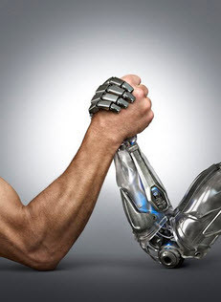 | Student B.  You firmly believe in the future of everything robotic and artificial. Prepare a short talk (5-7 sentences) to convince your opponents. Use the ideas below and the TOO/ (NOT) ENOUGH TO structure

E.G. Robots are too primitive to generate ideas. or Robots are smart enough to fly airplanes.
Robots | advanced | to be used as a toy
Humans | cheap | to create art
Artificial intelligence | creative | to fly an airplane
 | expensive | to generate ideas
 | primitive | to make decisions
 | reliable | to operate in extreme environments
 | smart | to rule the human world
 | strong | to take care of babies and children
 | sturdy | to work 24/ 7
 | valuable
 | + etc

40 Match the diagrams to their names.

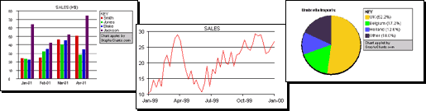
PIE CHART

BAR CHART

GRAPH

41 Study the instruction

HOW TO DESCRIBE A DIAGRAM
1. State the type of diagram and what it is about.
2. Write about the data you see
- generalize
- do not write about everything
- write about the biggest/ smallest/ most important
- try not to use the exact numbers
- pay attention to the past/ present/ future tenses
3. In conclusion write about the trend you noticed.

Useful vocabulary

↑ to increase/ grow/ go up/ rise/ double
↓ to decrease/ fall/ go down/ drop
≈ to remain the same/ to remain stable
the number of/ the share of/ the percentage of
dramatically/ sharply/ rapidly/ steadily
by 100500
by ten percent/ by 50%
3-5 times
tenfold

42 In pairs study the chart and answer the questions

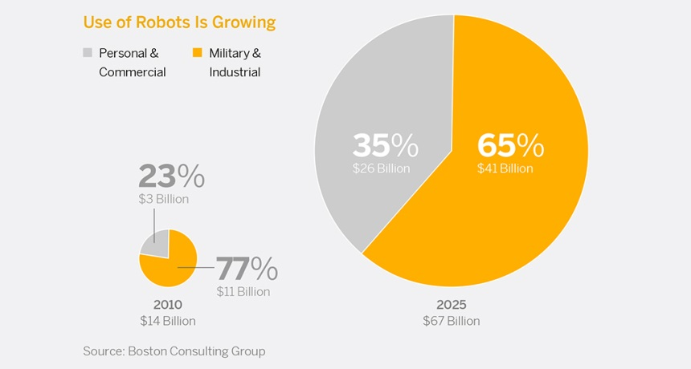
1. What type of chart is this? What does it show?
2. How is the total number of robots expected to change?
3. How is the structure of market going to change?
4. What trend(s) can be observed?

43 Order the sentences using the instruction in Ex. 37.

- According to the chart, the robotic market will grow more than four times over the 15 years’ period.
- Also, the share of personal and commercial robots is expected to rise from less than a quarter to over a third of the total robots’ market.
- It compares the usage of personal and commercial robots with the usage of military and personal robots.
- So there are two definite trends: firstly, the use of robots will continue to grow, secondly, robots will be used in everyday life more often.
- The pie chart created by Boston Consulting Group shows robots’ usage in 2010 and 2025.

44 Study the chart and fill in the gaps in its description.

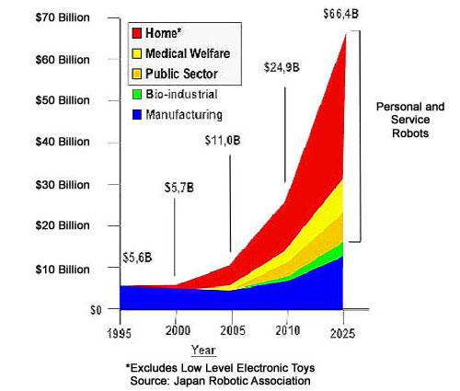
The graph __________ the change in robotic market ____ 30 years’ period from 1995 __ 2025. The graph focuses on the increase in ______ and ______ robots. In ____ these robots were totally absent from the market. The only robots available at that time were ______ ____, whose _____ remains more or less ______ over the entire period. The dramatic twelve____ growth of the robotic market by 2025 will be due to the increase __ the _______ of home, medical and public sector service robots. These robots will take up about _______ quarters of the market. So there are ____ definite trends: ______, in 2025, the robotic market will be much ______ than it is today, secondly, it will be dominated by ______ ___ ______ _______.

45 *Choose one of the charts and write its description.
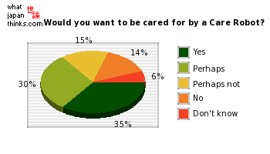
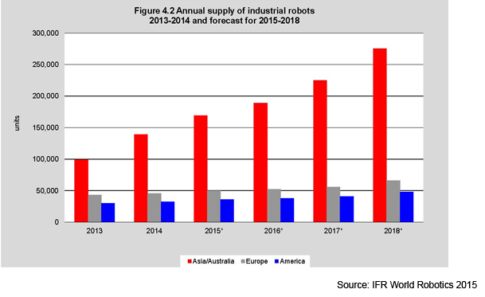

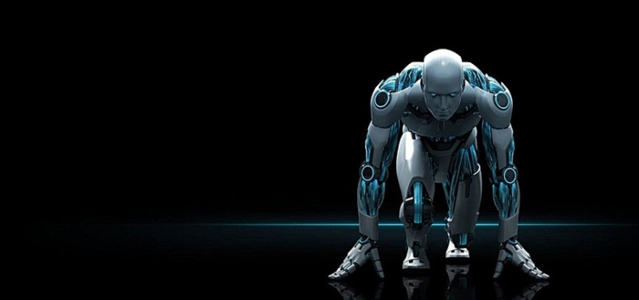

Module 9 Lesson 4 ROBOTIC CHALLENGE

46 Choose the word which cannot be used with the word in BOLD.

handle/ perform/ solve/ tackle PROBLEMS

CORE component/ function/ structure/ centre

perform/ tackle/ serve/ do TASKS

solve/ overcome/ navigate/ create OBSTACLES

PERFORM tasks/ chores/ obstacles/ jobs

47 Brainstorm dangerous environments for robots to work in.

- Natural disasters: …
- Human caused catastrophes: …
- Remote areas on Earth and outside: …

48 Watch the video about DARPA Robotic Challenge and mark the tasks the robots were to do
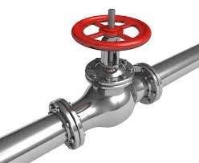
- climb a ladder
valve
ladder
- dispose of a bomb
- drill holes in metal
- open a door
- put out a fire
- twist a valve
- walk on difficult terrain

49 Watch the video again and fill in the gaps.

The DARPA robotic challenge is meant to test robots’ performance in ….. . The competition attracted all sorts of participants: government, ………….. and ………….. institutions. One of the robots presented by NASA is meant to work in ……….. . Another NASA robot was inspired by an ape and can use …. or ….. legs to move.

The tasks for the robots were designed to …………. actions in a catastrophic event. Some of the robots did not take part in the challenge and were there to demonstrate the ……….. of the cutting-edge robotics. However, it was clear from the show that the development is certain to be followed with ….. . The team from …. won the challenge. It earned ….. out of ……. points.

50 Read one of the texts below and prepare to discuss it in a small group.

- What environment are these robots designed for?
- What specific features do they have?
- What can they do?
- How are these robots controlled?
- What is the main difference between these robots?
- What do you think about the effectiveness of these robots?

TEXT 1
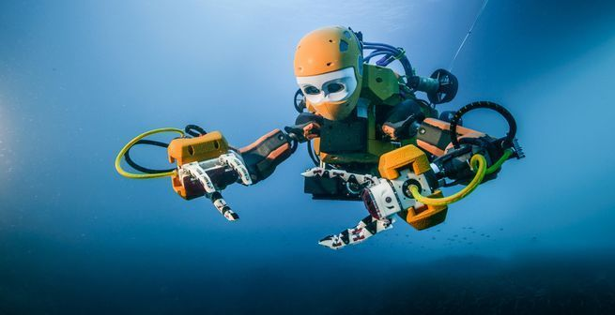
OceanOne, a robot avatar lets humans explore deep under the Ocean's surface, without any of the dangers or time limits associated with diving.
While a human diver is constrained by annoying things like air and pressure when doing underwater research or excavations, a robot can stay underwater for much longer, collecting samples in hostile underwater environments. Unlike submarines, which have limited ability to take delicate samples, and have tools that require extensive training to use, OceanOne is controlled by haptic joysticks, letting its operators feel the lightness or heaviness of whatever object it's holding, thus giving researchers a much more hands-on feel.
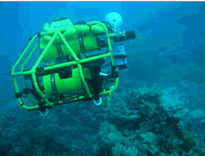
The Australian Centre for Field Robotics at the University of Sydney developed a prototype for autonomous underwater robots that may one day explore and monitor the Great Barrier Reef. At present this robot (called Oberon) must remain connected to a ship on the surface, but within a decade it would be possible for robots to be lowered to the ocean floor and left to get on with mapping the terrain on their own. Oberon has two scanning sonars and a depth sensor as well as a color camera. It does not need any independent information, such as from GPS satellites, to work out where it is.
haptic тактильный, осязательный

TEXT 2

- What environment are these robots designed for?
- What specific features do they have?
- What can they do?
- How are these robots controlled?
- What is the main difference between these robots?
- What do you think about the effectiveness of these robots?

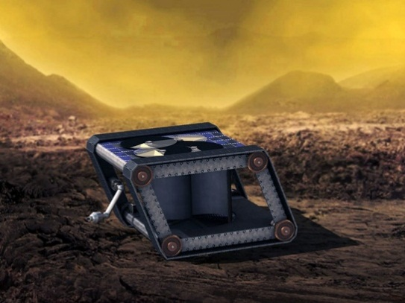
Venus is not pleasant. Its surface, approximately 850 degrees Fahrenheit, is hot enough for paper to spontaneously combust. Its atmosphere is dense enough to crush a submarine.
The concept rover, called AREE (Automation Rover For Extreme Environments), is a mechanical rover that works with minimal electronics. The boxy, tank-like bot rolls around on treads, making it resistant to Venus’ rough terrain. Those treads are powered via a wind turbine that captures the planet’s winds and stores that power for the various systems on the rover. The Venus rover will use a simple optical reflector to transmit its data to orbiting satellites by flashing radar light like Morse code.
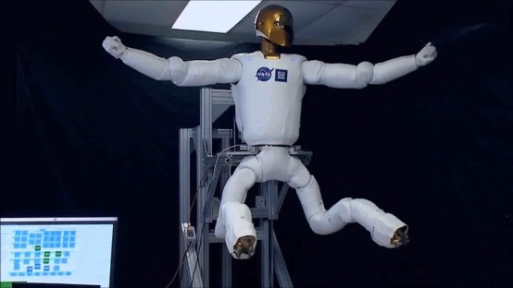
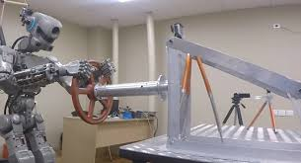
The Russian space agency is planning to send its humanoid robot Fedor to the International Space Station. Fedor stands for Final Experimental Demonstration Object Research and seems to have been developed as a fighting robot. Fedor can shoot guns, drive cars and use a variety of tools, including drills.
As well as Fedor, another humanoid robot is being developed for the ISS. That one is called Robonaut and is a product of NASA. Robonaut – which didn’t have any legs at first, just upper body, head and arms – has already been on the ISS, but has been broken for years. NASA is planning to make Robonaut fully operational again, possibly adding legs as well, although they look more like industrial robotic arms.

treads гусеницы

TEXT 3
- What environment are these robots designed for?
- What specific features do they have?
- What can they do?
- How are these robots controlled?
- What is the main difference between these robots?
- What do you think about the effectiveness of these robots?
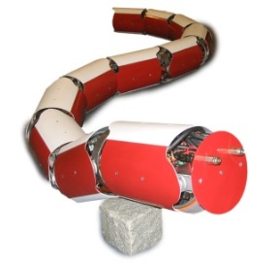
Anna Konnda is a water-powered hydraulic robot snake. It is driven by twenty custom-built water hydraulic cylinders. The snake measures 3 meters long and weighs 75 kilograms. The control of this robot is realized using numerous microprocessors that control the joints. The main controller can be connected to a PC via a Bluetooth connection.
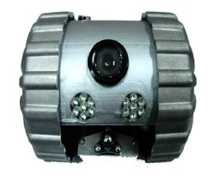
Developed by Hoya Robot Company and financed by the South Korean government, this robot is intended to be used by firefighters as their personal spy. Despite its heavy armor and robust look, it measures only 12.5 centimeters in diameter and weighs 2 kilograms.
This robotic device can be thrown into a building on fire and operate there for 30 minutes. As it can withstand temperatures up to 320F (160C), firefighters can explore the environment and plan their actions accordingly using this remote controlled robot.

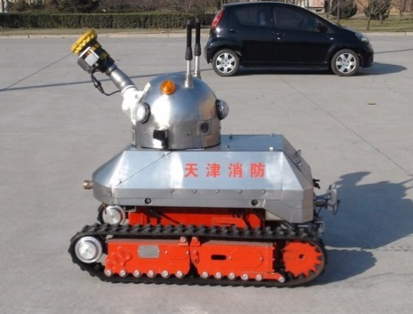
The Firemote, designed by Ryland Research Limited, weighs around 450 kilograms. This robot is remote controlled (up to 300 meters); it can withstand high temperatures as well as extinguish fire using either water or foam. In addition to these "basic" capabilities there are also some quite unique ones.
Battery compartments are changeable thus allowing changing batteries instead of charging them. The robot is also equipped with four color cameras that together provide a panoramic view and one infrared camera steerable in horizontal plane.

extinguish тушить

CONSOLIDATION

1. Choose the correct option in each statement.

- A robot is a machine defined/ designed to execute one or more tasks automatically.
- Robots perform/ serve a multitude of different jobs.
- A typical robotic arm is made up of seven metal segments, joined by six joints/ links.
- A robotic arm can be used for drilling/ tightening bolts and screws.
- Advances in robotics are going to have huge implications/ obstacles for the humanity.
- Neural networks help robots quickly and accurately grasp/ perform objects.
- A bar/ pie chart represents different amounts by thin vertical or horizontal rectangles.
- To operate, a robot needs sensor inputs/ outputs and action inputs/ outputs.

2. Find the English equivalents for the following using Essential vocabulary

Входные и выходные данные
Гистограмма
Датчик силы зажима
Десятикратный рост
Звено робота
Круговая диаграмма
Логические рассуждения
Локтевой шарнир
Опасные ситуации
Основной компонент
Pаздел науки
Увеличение доли служебных роботов

Браться за сложные задачи
Делать точные отверстия
Иметь значение для всей отрасли
Обходить препятствия
Помогать человеку в повседневных делах
Работать в опасных условиях
Работать лучше, чем человек

В свою очередь
В ином случае

3 Transform the sentences by changing the part in italics to include the word in brackets ( ).
Spectators at DARPA challenge watched how robots navigated obstacles. (…NAVIGATE…)
Spectators at DARPA challenge watched robots navigate obstacles.
- Engineers closely observed how their inventions performed. (…PERFORMING…)
- Everyone expected that their robot would win. (…TO…)
- No one wanted that their robot would fail. (…TO…)
- People suspect that the robots may be used for military purposes. (…TO…)
- It is likely that robots will replace people in dangerous environments. (ROBOTS ARE…)
- Some of the robots will certainly be used. (… ARE …)
- It was important that a robot completed all the tasks. ( … FOR …)
- Some robots are so sturdy that they can function in the fire. ( … ENOUGH TO …)
- Other robots were not so reliable that they could continue. ( … ENOUGH TO ….)
- The prize was so big that it could not be ignored. ( … TOO BIG …)

4 Use the mind map as a basis to design your robot for a particular mission and environment.

